 |  |  |  | команда | ______________
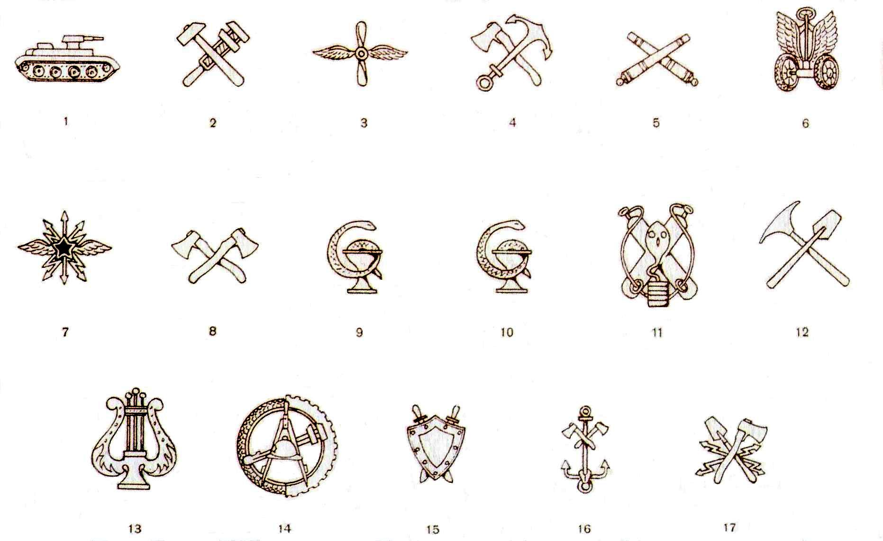

1 |  | 11
2 |  | 12
3 |  | 13
4 |  | 14
5 |  | 15
6 |  | 16
7 |  | 17
8 |  | 18
9 |  | 19
10 |  | 20

